Tam Doan

017660342

Min He

Lab Report

Schematic

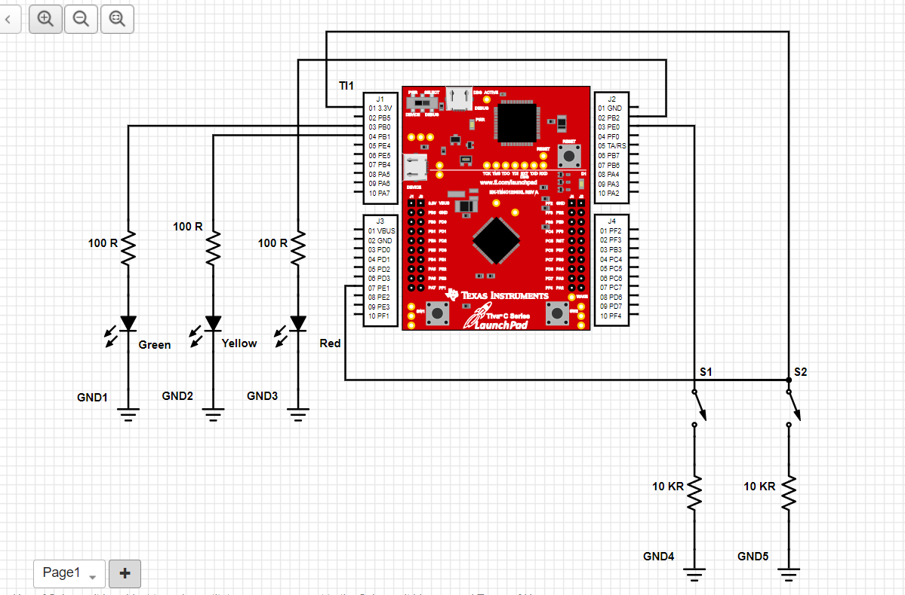

The Board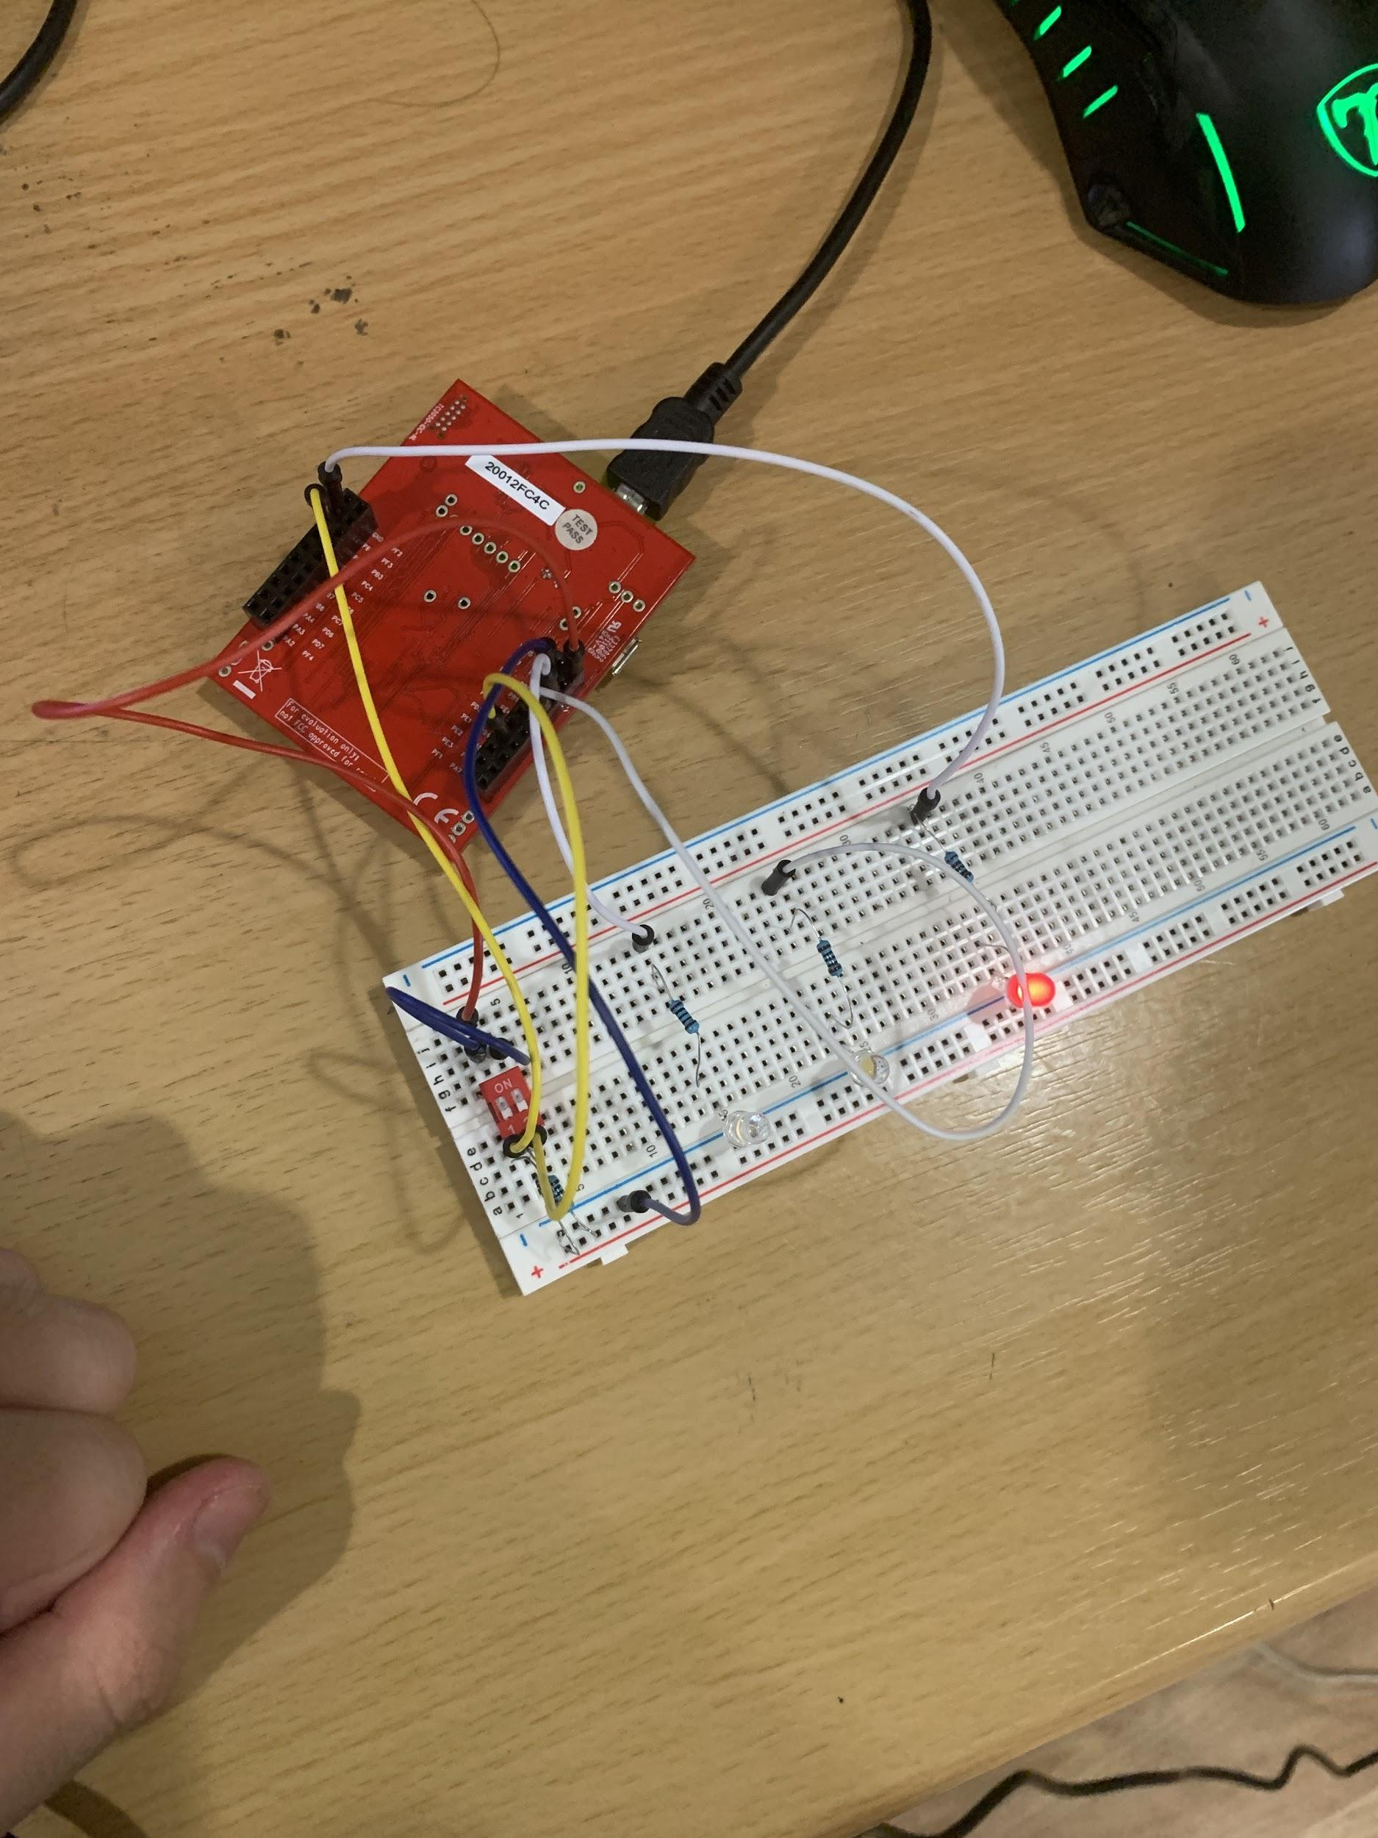

Link To The Video

<https://youtu.be/hNfRV8F21jE>

Lab Description

The lab simulates the interaction between 3 LEDS and 2 switches on the breadboard. The 3 LEDS are green, yellow, and red, and the 2 switches perform different functions upon the LED. Turning on switch 1 will transition the LED to the next state of LED, so green to yellow and yellow to red. Turning on switch 2 will have the current LED blink. Turning on both switches will have the LED blink and transition to the next state after a blink. The lab is simulated on KIEL and then loaded on to the board to be demonstrated. Finally the other part of the lab is to create a schematic along with actually making the circuit on a breadboard. Overall this lab was a challenge, as I personally have never had to deal with ports and initializing them before. The creation of the circuit and schematic was relatively simple, but the software portion was trouble for me.